CBS
Colegio Bautista Shalom



English Course 5
Fifth Grade
Second Bimester

Contents

PRESENT PROGRESSIVE

- PRESENT PROGRESSIVE – FORM
- TIPS ON HOW TO FORM NEGATIVE SENTENCES AND QUESTIONS
- PRESENT PROGRESSIVE – EXCEPTIONS IN SPELLING

PAST PROGRESSIVE (PAST CONTINUOUS)

- FORM
- EXCEPTIONS IN SPELLING
- USE OF PAST PROGRESSIVE
- SIGNAL WORDS OF PAST PROGRESSIVE

FUTURE PROGRESSIVE

- FUTURE PROGRESSIVE
  - USED TO
  - FORM
  - SIGNAL WORDS
- FUTURE II PROGRESSIVE
  - FORM
  - USE
  - SIGNAL WORDS
- FUTURE I SIMPLE GOING TO
  - FORM OF GOING TO FUTURE
  - USE OF GOING TO FUTURE
- FUTURE “TIME CLAUSES”

NOTE: As you progress in learning each of the topics developed you will find exercises to solve with the help of your teacher.
PRESENT PROGRESSIVE

The present progressive puts emphasis on the course or duration of an action.

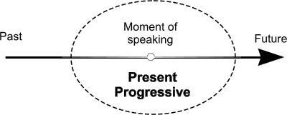
The present progressive is used for actions going on in the moment of speaking and for actions taking place only for a short period of time. It is also used to express development and actions that are arranged for the near future.

PRESENT PROGRESSIVE – FORM

Use a form of to be and the infinite verb plus -ing.

Use:
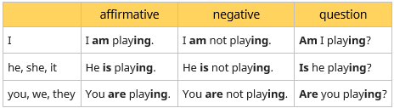
- am with the personal pronoun I.
- is with the personal pronouns he, she or it (or the singular form of nouns).
- are with the personal pronouns you, we, they (or the plural form of nouns).

TIPS ON HOW TO FORM NEGATIVE SENTENCES AND QUESTIONS

In negative sentences, we put not between the form of be and the verb.

In questions, we simply swop the places of subject and the form of be.

EXERCISE ON FORM. Complete the table with the correct forms.
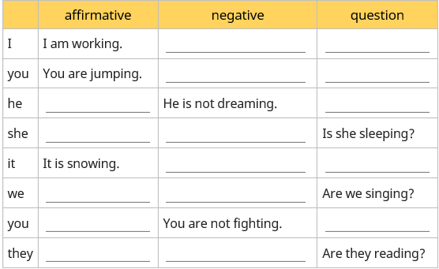

EXERCISE ON AFFIRMATIVE SENTENCES. Use the words below to make sentences in present progressive.

- I / to read a book _________________________
- it / to rain _________________________
- he / to repair his bike _________________________
- they / to watch a film _________________________
- the cat /to sleep on the chair _________________________
- Jane and Emily / to do their homework _________________________
- Bill / to wait at the bus stop _________________________
- we / to listen to the radio _________________________
- the children / to play a game _________________________
- Laura / to walk the dog _________________________

PRESENT PROGRESSIVE – EXCEPTIONS IN SPELLING

A single, silent e at the end of the word is dropped before ing.

example: come – coming
I am coming home. You are coming home. He is coming home.

But: ee at the end of the word is not changed

example: agree – agreeing

The final consonant after a short, stressed vowel is doubled before ing.

example: sit – sitting
I am sitting on the sofa. You are sitting on the sofa. He is sitting on the sofa.

The letter l as final consonant after a vowel is always doubled before ing.

example: travel – travelling
I am travelling around. You are travelling around. He is travelling around.

Mind: This applies only for British English; in American English there is usually only one l.

An ie at the end of a word becomes y before ing.

example: lie – lying
I am lying in bed. You are lying in bed. He is lying in bed.

EXERCISE ON EXCEPTIONS 1:

Write down the ing form of the following words. Mind the exceptions in spelling.

- make : making
- have ________________
- sit ________________
- run ________________
- lie ________________
- stop ________________
- model ________________
- get ________________
- travel ________________
- tie ________________

EXERCISE ON EXCEPTIONS 2:

Use the words below to write sentences in present progressive. Note that sometimes there are exceptions in spelling when adding 'ing'.

- He / to get / pretty nervous ___________________
- She / to write / a letter ___________________
- We / not / to work ___________________
- They / to argue ___________________
- Look! / The dog / to pee / on the carpet ___________________
- I / to meet / my friends tonight ___________________
- He / to travel / a lot ___________________
- The kids / to play / in the garden ___________________
- She / to enter / the house ___________________
- They / to tie / still ____________________

PAST PROGRESSIVE (PAST CONTINUOUS)

The past progressive puts emphasis on the course of an action in the past.

FORM
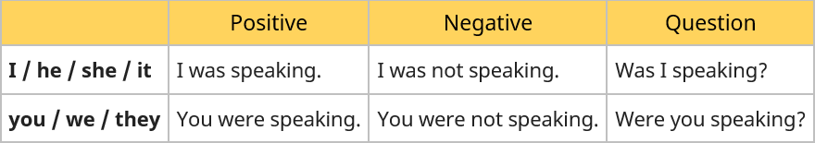

EXCEPTIONS IN SPELLING
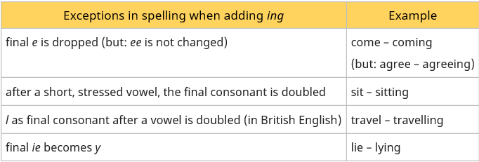

USE OF PAST PROGRESSIVE

- puts emphasis on the course of an action in the past.

Example: He was playing football.

- two actions happening at the same time (in the past).

Example: While she was preparing dinner, he was washing the dishes.

- action going on at a certain time in the past

Example: When I was having breakfast, the phone suddenly rang.

SIGNAL WORDS OF PAST PROGRESSIVE

- while, as long as

EXERCISE ON PAST PROGRESSIVE 1. Exceptions in Spelling when Adding ing.
Write down the ing form of the following words. Mind the exceptions in spelling.
- live _________________
- run _________________
- give _________________
- swim _________________
- lie _________________
- sit _________________
- travel _________________

EXERCISE ON PAST PROGRESSIVE 2. Was or Were.

Decide whether to use 'was' or 'were'.

- Boris ____________learning English.
- They _______________swimming in the lake.
- Your father_______________ repairing the car.
- I _______________reading a magazine.
- You ______________packing your bag.
- My friends ______________watching the match on TV.
- It________________ raining.
- The dog _______________barking.
- The children _______________ brushing their teeth.
- Anne and Maureen _______________singing a song.
EXERCISE ON PAST PROGRESSIVE 3. Positive Sentences.
Write positive sentences in past progressive.
- you / play / cards ________________________
- Alice / walk / around the lake ________________________
- Caron / listen / to the radio ________________________
- we / read / a book about Australia ________________________
- Linda / look for / her ring ________________________
- Fiona and Sam / visit / the castle ________________________
- Ben / wash / the car ________________________
- Kim and I / wait / in the park ________________________
- My sister / feed / the birds ________________________
- Greg and Phil / count / their money ________________________

EXERCISE ON PAST PROGRESSIVE 3. Put the verbs into the correct form (past progressive).

- When I phoned my friends, they (play)_______________ monopoly.
- Yesterday at six I (prepare)_______________ dinner.
- The kids (play)_______________ in the garden when it suddenly began to rain.
- I (practise)_______________ the guitar when he came home.
- We (not / cycle)_______________ all day.
- While Aaron (work)______________ in his room, his friends (swim)___________ in the pool.
- I tried to tell them the truth but they (listen / not)_______________
- What (you / do)______________ yesterday?
- Most of the time we (sit)____________ in the park.

USED TO

FORM

[used to + VERB]

Example:

I used to go to the beach every day.

It is better not to use "used to" in questions or negative forms; however, this is sometimes done in informal spoken English. It is better to ask questions and create negative sentences using Simple Past.

USE 1 Habit in the Past.


Used to" expresses the idea that something was an old habit that stopped in the past. It indicates that something was often repeated in the past, but it is not usually done now.

Examples:

- Jerry used to study English.
- Sam and Mary used to go to Mexico in the summer.
- I used to start work at 9 o'clock.
- Christine used to eat meat, but now she is a vegetarian.

USE 2 Past Facts and Generalizations
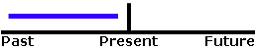

"Used to" can also be used to talk about past facts or generalizations which are no longer true.

Examples:

- I used to live in Paris.
- Sarah used to be fat, but now she is thin.
- George used to be the best student in class, but now Lena is the best.
- Oranges used to cost very little in Florida, but now they are quite expensive.

"Used to" vs. Simple Past

Both Simple Past and "Used to" can be used to describe past habits, past facts and past generalizations; however, "used to" is preferred when emphasizing these forms of past repetition in positive sentences. On the other hand, when asking questions or making negative sentences, Simple Past is preferred.

Examples:

- You used to play the piano.
- Did you play the piano when you were young?
- You did not play the piano when you were young.

ACTIVE / PASSIVE

Examples:

- Jerry used to pay the bills. Active
- The bills used to be paid by Jerry. Passive

EXERCISE USED TO + INFINITIVE 1. Make an affirmative sentence, negative sentence or question using ‘used to + infinitive’:

1) I / live in a flat when I was a child.
_______________________________________________________________
2) We / go to the beach every summer?
_______________________________________________________________
3) She / love eating chocolate, but now she hates it.
_______________________________________________________________
4) He / not / smoke.
_______________________________________________________________
5) I / play tennis when I was at school.
_______________________________________________________________
6) She / be able to speak French, but she has forgotten it all.
_______________________________________________________________
7) He / play golf every weekend?
_______________________________________________________________
8) They both / have short hair.
_______________________________________________________________
9) Julie / study Portuguese.
_______________________________________________________________
10) I / not / hate school.
_______________________________________________________________
FUTURE PROGRESSIVE

Future I progressive puts emphasis on the course of an action taking place in the future.

FORM

- A: He will be talking.
- N: He will not be talking.
- Q: Will he be talking?

USE

- action that is going on at a certain time in the future.
- action that is sure to happen in the near future.

SIGNAL WORDS

- in one year, next week, tomorrow.

EXERCISE ON FUTURE I PROGRESSIVE. Put the verbs into the correct form (future I progressive).

- At midnight we (sleep)_______________________
- This time next week we (sit)__________________ at the beach.
- At nine I (watch)__________________ the news.
- Tonight we (cram up)_______________________ for our English test.
- They (dance)________________________ all night.
- He (not / play)______________________ all afternoon.
- I (not / work)______________________ all day.
- (eat / you) ________________________at six?
- (drive / she)______________________ to London?
- (fight / they)_____________________ again?
FUTURE II PROGRESSIVE

Future II progressive puts emphasis on the course / duration of an action taking place before a certain time in the future. It can also be used to express an assumption regarding a future action.

Future II progressive is not used very often as it can usually be replaced by future II simple.

FORM

- A: He will have been talking.
- N: He will not have been talking.
- Q: Will he have been talking?

USE

- action taking place before a certain time in the future.
- puts emphasis on the course of an action.

SIGNAL WORDS

- for …, the last couple of hours, all day long.

EXERCISE ON FUTURE I PROGRESSIVE.
Put the verbs into the correct form (future II progressive).

- By the end of the week I (work)______________________ here for four months.
- By the end of this month we (live)_____________________ together for six years.
- By the end of the term she (study)___________________for nine years.
- By midnight we (play)___________________ this computer game for 48 hours.
- She (talk)_________________________ on the phone for the last couple of hours.
- They (look for)____________________ me all night long.
- He (play)________________________ soccer all day long.
- You (watch)_________________ TV all the time.
- He (not / sleep)_______________________ all morning.
- (wait / they)__________________________ for 2 hours?

FUTURE I SIMPLE GOING TO

Going to future expresses a conclusion regarding the immediate future or an action in the near future that has already been planned or prepared.

FORM OF GOING TO FUTURE

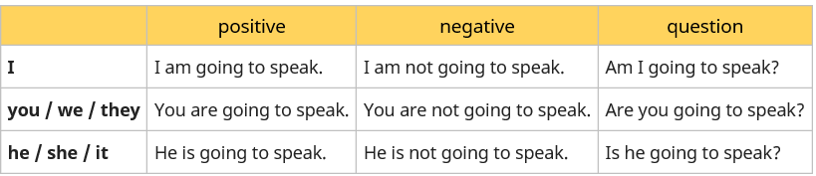

USE OF GOING TO FUTURE

- an action in the near future that has already been planned or prepared

Example: I am going to study harder next year.

- a conclusion regarding the immediate future

Example: The sky is absolutely dark. It is going to rain.

EXERCISE ON FUTURE I SIMPLE (GOING TO). Write positive sentences in going to future.

- I / work _______________________
- you / dance ____________________
- it / rain _______________________
- they / ask _____________________
- he / stays _____________________
- we / speak ____________________
- I / give _______________________
- she / try ______________________
- they / help ____________________
- he / push______________________
The following people are about to do something. You can see that they have already planned or prepared the action.

Write positive sentences in going to future.

- What does she need the telephone for?
→ (she / call / her boyfriend)_________________________
- Why are they wearing sport suits?
→ (they / play / squash)____________________________
- Why has Fiona bought chocolates?
→ (She / visit / her grandma)________________________
- Why do you need a map?
→ (we / walk / in the mountains)___________________________
- What do you need the cloth and the bucket for?
→ (we / wash / the car)_________________________
- Why are you running about with the toothbrush?
→ (I / brush / my teeth)_________________________
- Why is daddy not coming with us?
→ (he / repair / the car)__________________________
- Hurry up!
→ (they / light / the bonfire)_______________________
- Why are all these tapes on the table?
→ (we / learn / Greek)____________________________
- What do you need the pen for?
→ (I / write / some postcards)________________________
EXERCISE ON FUTURE I SIMPLE (GOING TO).
The following people do not intend to do the following actions.
Write negative sentences in going to future.
- (I / sell / my car)_________________________
- (he / help / us)__________________
- (they / study / harder)___________________
- (we / cook / dinner tonight)_____________________
- (I / celebrate / my birthday this year)____________________
- (she / clean / her room)_______________________
- (they / move / house)_______________________
- (she / stay / with Amy)_____________________________
- (they / change / their clothes)________________________
- (we / get up early / next Sunday)______________________________
EXERCISE ON FUTURE I SIMPLE (GOING TO). Write questions in going to future.

- (he / cook dinner / tonight)____________________
- (you / run / in the race)______________________
- (they / climb / that mountain)__________________
- (she / exercise / at the gym / in the afternoon)__________________
- (you / carry / that heavy box)____________________
- (computer / crash)____________________
- (we / eat / fish / tonight)___________________
- (he / play football / tomorrow)________________
- (Lucy / call / a taxi)________________________

FUTURE “TIME CLAUSES”

When writing sentences with respect to the future this has two parts:
- Main clause: use "goes" or "goes to"
- Time clause: the present simple is used.

Example:

She will look for a job when she graduates.
He's going to get a job when he graduates.

The "clause of time" can begin before the prayer.

Example:

Before she asks, she will visit the school

OR
She will visit the school before she asks.

Common expressions of time to construct sentences in the future

When, then, not until and as soon as

A) When disclosing events that occur first

Example:

When I graduate, I will look for a job.

I'll get a job after graduation.
I will not look for work until I graduate.
As soon as I graduate, I will look for a job.

B) Before, until, at the moment, for the moment, to give the event of events occurring in the second term.

Example:

Before I get a job, I will finish school.

I'll stay at school until I get a job.

By the time I get a job, I'll be out of school.

C) "While" reports an event that will occur at the same time as another event.

EXERCISE FUTURE TIME CLAUSES. Choose the correct answer.
Principio del formulario
- I'll do my homework before I________________________TV.
- We'll go to the cinema as soon as we ____________________work.
- While Richard is watching the game this afternoon, he_________________ his phone.
- Before dad arrives home, I____________________ this essay.
- I'll have a shower when I__________________________ breakfast.
- After Jane leaves home, she _____________________ her friends.

